Framework Part-8

Integrating Cucumber wrapper into Selenium Framework

Cucumber Terminologies
- Gherkin:- Language to describe software behaviour. Language to define test case.
- Normally we write test case in english. Eg. check credit card payment or loan payment. If BA wants to show business requirement , he has to define that in gherkin syntax. To avoid misleading of interpretation because QA has different statement which may contradict developers opinion.
- Keywords used in Cucumber:-
- Scenario
- Feature
- Feature File
- Scenario Outline
- Step Definition
- Scenario
- In cucumbers, test cases are represented as scenarios. This test case is represented in gherkin style.
- Gherkin Syntax: Given/When/Then/But/And
Given
BA wants to express Credit Card payment scenario by selecting minimum amount option. If bill is 500$ & min payment is 25$ so there is an option to select minimum payment & you have to pay 25$. To express this gherkin will use Then, When & Given
- Given:- includes precondition to test. Eg- you should be on pay credit card page
- When:- what action you need to perform. It describes user action. Eg- to make this payment happen, what are the action you need to perform. Eg:- when user fills all details & select minimum amount option.
- Then:- Observes the expected output. Observation should be related to business value/benefit of future description.
- And:- used for statements that are in addition to previous steps and represent positive statements. If multiple validations are then then it get separated using “And” keyword.
- Used for statements that are an addition to previous steps & represent negative statements.
Scenario:- Make Minimum due payment.
Given- User is on pay credit card page.
When:- user fills all details & select minimum mount option.
And User clicks on pay button
Then credit Card confirmation page is displayed.
- Why there is need to convert scenarios into gherkin standard ? In cucumber, whatever line we define like above, we’ll tag our regular development automation code to each and every of this line. Code of navigation will be tied to “When” line.
- You’ll run this scenario(test case) in cucumber. As you tag each and every line to backend real code. Form here it’ll go to that particular code & execute them.
- For multiple actions we will use “And” keyword to concatenate our actions.
- But is used for negative scenario.
- Feature
- Represents business requirement. Eg- test the credit card payment flow.which is high level business requirement. Is is ur duty to derive as many test cases to verify that particular business requirement. Test this flow with multiple test cases. Cucumber expects the feature of those scenarios. . Eg- Feature- Credit Card Payment.
- Feature file is test suite which describe multiple test cases. QA wonder where exactly this all need to write. For selenium, we use java class but for cucumber we use feature file. Feature file is created as by giving .feature extension to it. Eg: payment.feature & dump all those scenarios into that file.
- Setting up cucumber dependencies into Framework and create feature files
- 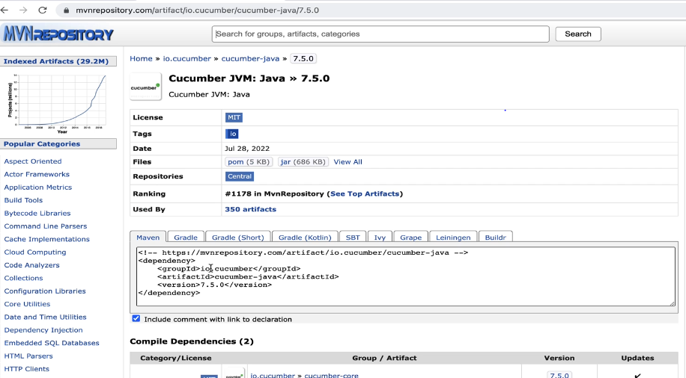
- 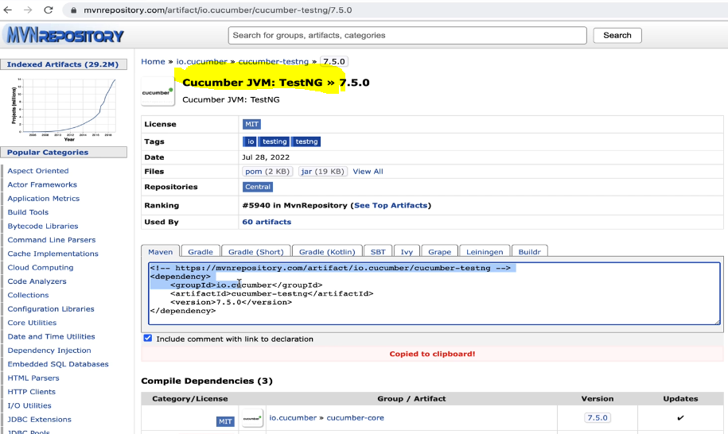
- 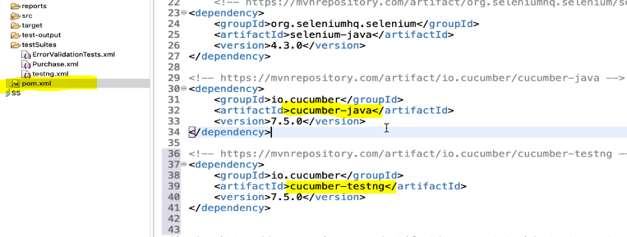
- This way QA can run cucumber java and testNG using cucumber wrapper.
- 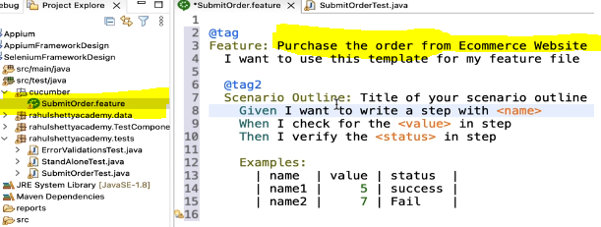
- This is wrapper of cucumber file in plain english language for the code written here. 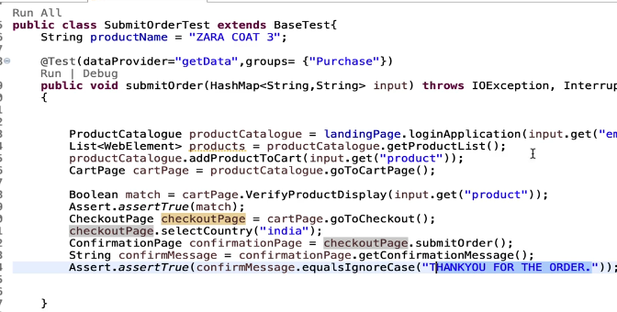
- First User need to land on application, which is prerequisite step. In cucumber, you can actually separate prerequisit test from your actual scenario. There is keyword named “Background” which executes before each and every scenario. To invoke browser, hit the URL before login. 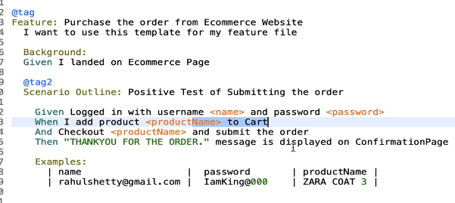

- Implement Step definitions for features and understand regular expressions
- Lets understand step definition method implementation for cucumber scenarios.
- Create new package - StepDefinition
